Tyler Burleson

CSCI 3020-01

Lab07-report

The following information is the raw results from the Weka application. Using a neural network algorithm was a stronger option to compared to others when predicting sleep patterns (100% accuracy). This was a strong option for sleep patterns, but was weak for health grade, getting under 25% accuracy. Instead, I used a logistic summary algorithm to receive a 92.5% accuracy prediction. An even stronger result came from a J48 decision tree (figure 1) predicting 100% accuracy for all 80 cases using HRV levels. If it was higher than 69.5 it answered true, if lower or equal it answered false.

**Multilayer Perceptron Summary (Sleep Pattern)**

Correctly Classified Instances 80 **100 %**  
Incorrectly Classified Instances 0 **0 %**  
Kappa statistic **1**    
Mean absolute error **0.0163**  
Root mean squared error **0.0444**  
Relative absolute error **3.2513 %**  
Root relative squared error **8.8855 %**  
Total Number of Instances **80**

**Logistic Summary(Health Grade)**

Correctly Classified Instances 74 **92.5 %**  
Incorrectly Classified Instances 6 **7.5 %**  
Kappa statistic **0.8477**  
Mean absolute error **0.0594**  
Root mean squared error **0.2242**  
Relative absolute error **11.977 %**  
Root relative squared error **44.9932 %**Total Number of Instances **80**

**Decision Tree Visualization J48(HRV)**

Correctly Classified Instances 80 **100 %**  
Incorrectly Classified Instances 0 **0 %**  
Kappa statistic **1**   
Mean absolute error **0**   
Root mean squared error **0**   
Relative absolute error **0 %**  
Root relative squared error **0 %**  
Total Number of Instances **80**

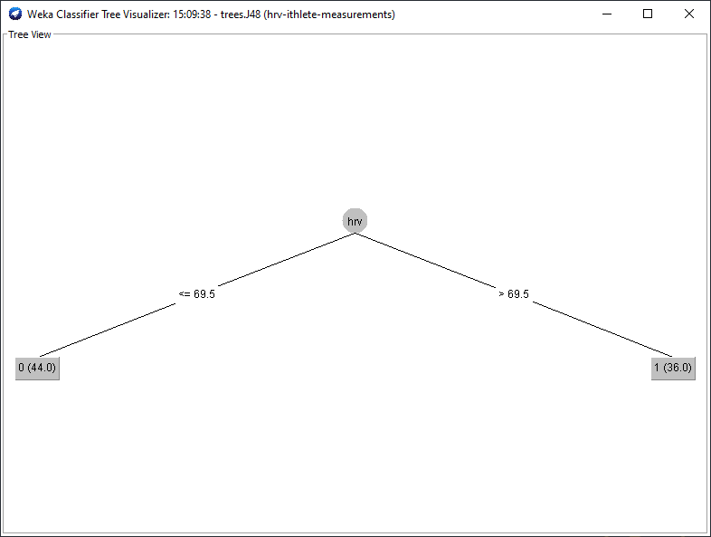

Figure